Test Cases



Table of Contents

1. Purpose of the document 3

2. Prerequisites 3

3. Test cases 3

Look Gallery 3

Product Detail Page Carousel 8

Homepage Carousel 10

# Purpose of the document

This document will describe the main test cases to ensure that everything that has been installed works properly.

# Prerequisites

Prior to testing the installed cartridge, please ensure:

* Mercaux cartridge has been installed according to the integration document
* All functionalities are enabled. Please refer to the User Guide section of the integration document to enable or disable the different functionalities

# Test cases

## 

## Look Gallery

If Look Gallery is enabled, you might want to control that everything is setup correctly.

In order to ensure that the Look Gallery is installed correctly, navigate to the homepage of the storefront for which you have activated the cartridge and the Look Gallery.

For example: **https://{domain}/on/demandware.store/Sites-{SiteID}-Site**

Looks should be visible in the Menu

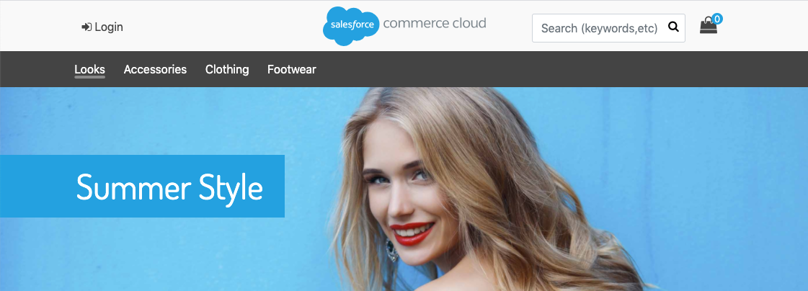

Control that the Looks link in the menu is redirecting to the Look Gallery page.

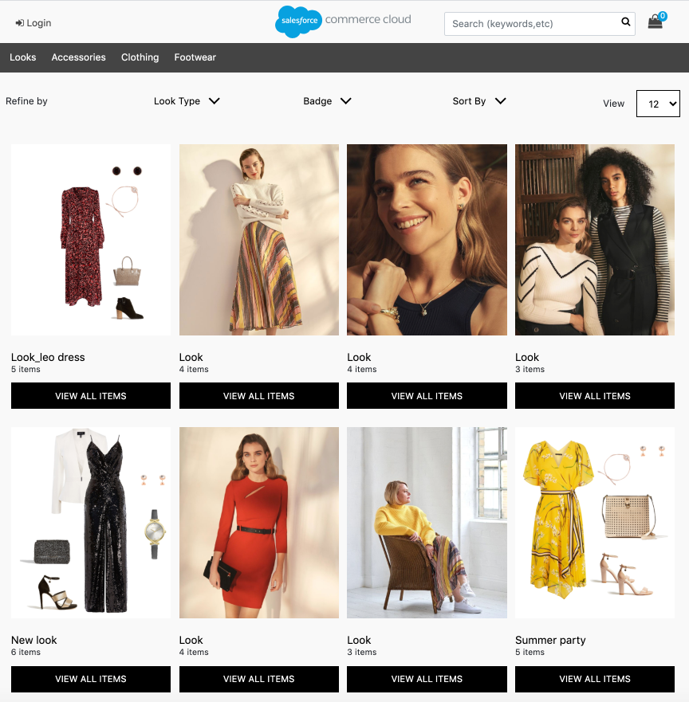

When clicking on one of the Look thumbnails, the Look pop-up must appear with a Look image and the products of the Look

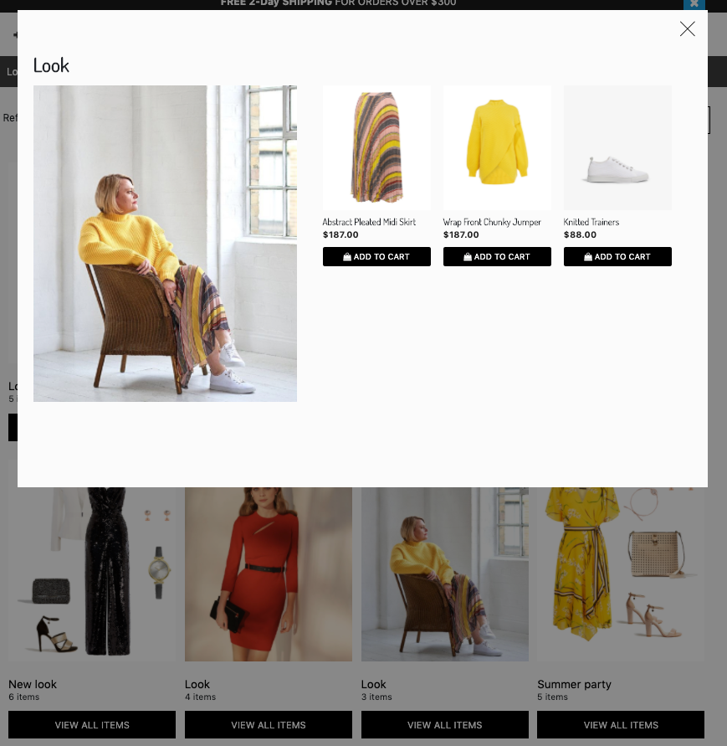

If you Add to Cart, when the product has multiple product variants such as sizes, you will be invited to select the size of the product you want to Add to the Cart. In case the product has only one size, the product will be added to the cart straight away.

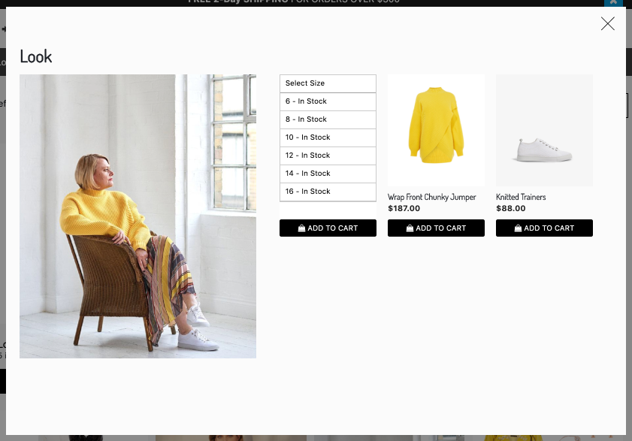

In a desktop context only, you will be able to navigate to a product detail pop-up by clicking on the image of a specific product. From the product detail pop-up, you can see the product details, select a size and add the product to your cart.

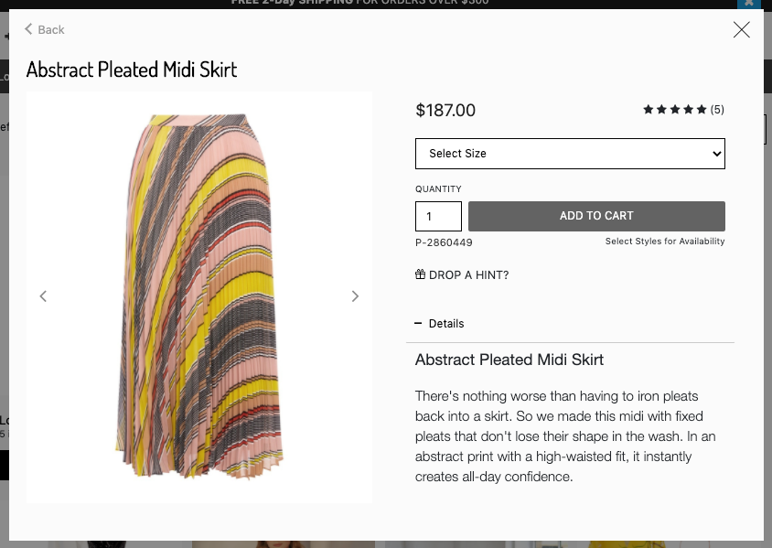

## 

## 

## 

## 

## 

## 

## 

## 

## 

## 

## 

## 

## 

## 

## Product Detail Page Carousel

When the Look carousel is enabled in product pages, in a product page where the product is part of at least one Look, a Shop the Look button will be displayed and redirects to the carousel of the Looks that contains this product.

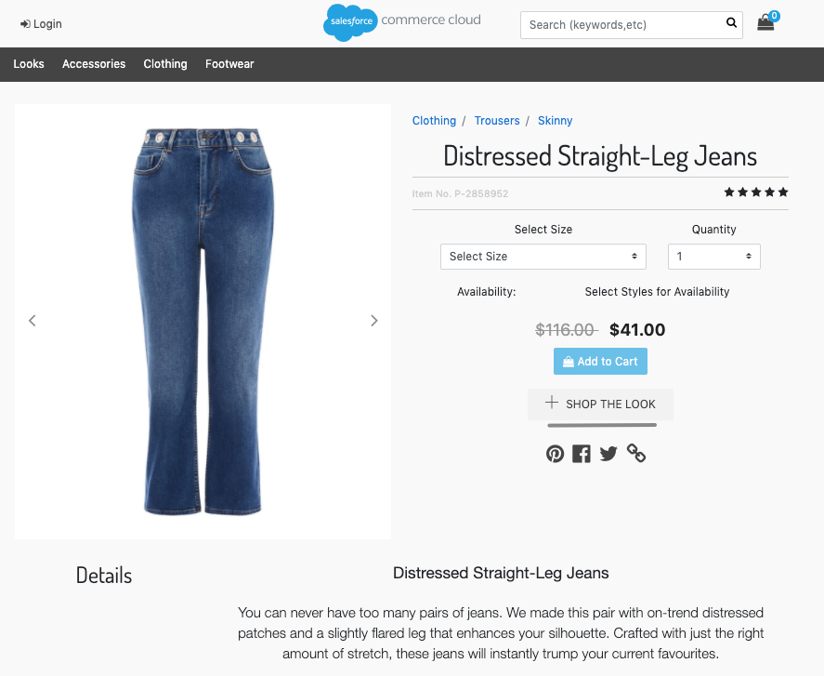

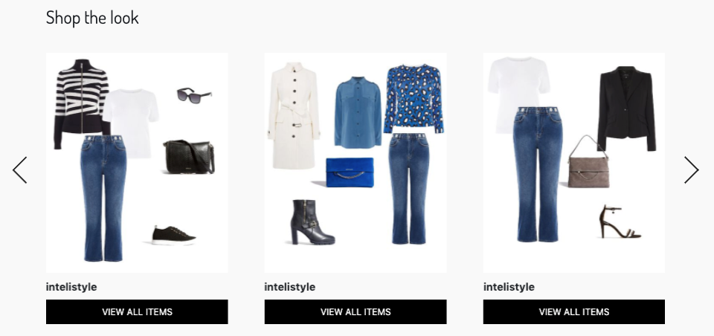

From the carousel, you must be able to have the same experience as in the Look Gallery described above:

1. Selecting a Look opens the Look pop-up with a Look image and the products of the Look
2. You can Add a product to your cart when clicking on the Add to Cart button and selecting a size (in case of multiple sizes for the product)
3. In a desktop context only, you will be able to navigate to a product detail pop-up by clicking on the image of a specific product. From the product detail pop-up, you can see the product details, select a size and add the product to your cart

## 

## 

## 

## 

## 

## 

## 

## 

## 

## 

## 

## 

## 

## 

## 

## 

## 

## 

## Homepage Carousel

On the homepage, a Look carousel must be displayed when the content slot is active.

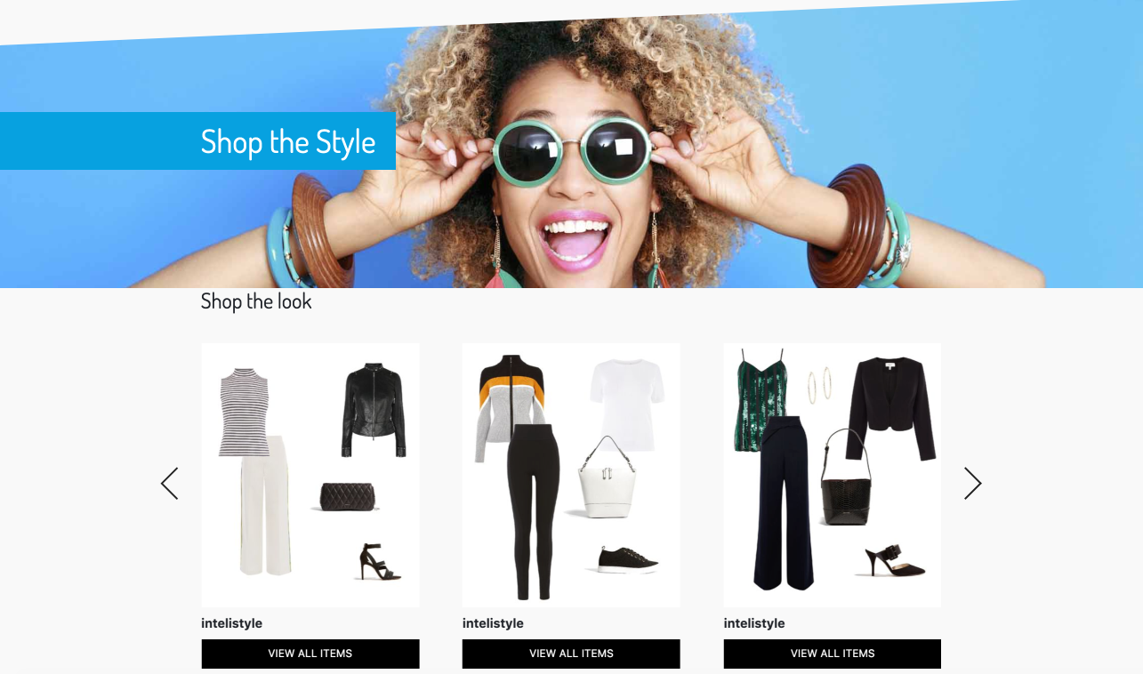

From the carousel, you must be able to have the same experience as in the Look Gallery described above:

1. Selecting a Look opens the Look pop-up with a Look image and the products of the Look
2. You can Add a product to your cart when clicking on the Add to Cart button and selecting a size (in case of multiple sizes for the product)
3. In a desktop context only, you will be able to navigate to a product detail pop-up by clicking on the image of a specific product. From the product detail pop-up, you can see the product details, select a size and add the product to your cart